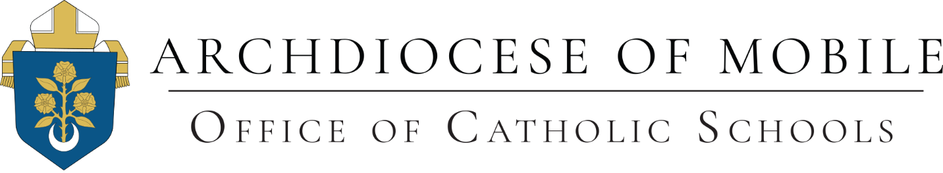

Immunization Requirement

1. All students enrolled in the Archdiocese of Mobile’s PreK – 12 Catholic schools, daycare centers and Mother’s Day Out programs will be required to be immunized. Parents must supply the school with evidence of immunization from the Alabama Department of Public Health.

2. A student may be exempt from immunizations for medical reasons. This is done by having a medical facility with a licensed physician provide a Certificate of Medical Exemption from school required immunizations. The Certificate of Medical Exemption, approved by the Alabama Department of Public Health, will be accepted in lieu of the Certificate of Immunization. The medical professional will complete the Certificate of Medical Exemption by entering the child’s information on the Alabama Department of Public Health’s data program, Imprint.

As has been indicated by the Vatican Pontifical Academy for Life, Catholics may seek immunizations for their children in good conscience. When it is a question of protecting the whole population and avoiding death and malformation in others, this becomes more important than an individual student’s objection to abstaining from vaccines developed from abortions that might have occurred decades ago. Catholics are responsible for the common good. Until such time that the Vatican were to alter this position, the Archdiocese of Mobile does not accept a religious objection to immunization based upon Catholic teachings.

